A Comparative Investigation of Prediction Accuracy of Judgement in Civil Case Verdicts: Decision Tree Model vs. Random Forest Algorithm
K.S.Bharathwaj  Department of Computer Science and Engineering,  Saveetha School of Engineering,  Saveetha Institute of Medical and Technical Sciences,  Saveetha University, Chennai, Tamil nadu, India, Pincode: 602105  192124033.sse@saveetha.com | S. Kalaiarasi  Department of Computer Science and Engineering,  Saveetha School of Engineering,  Saveetha Institute of Medical and Technical Sciences,  Saveetha University, Chennai, Tamil nadu, India, Pincode: 602105  kalaiarasis.sse@saveetha.com

Abstract — This research endeavors to conduct a comprehensive comparative investigation into the prediction accuracy of civil case verdicts within the legal framework, focusing on the Decision Tree Model and the Random Forest Algorithm. The study comprises two distinct groups, each consisting of 1000 rows of diverse court case details, strategically selected for robust model testing in a controlled university laboratory setting. Implementation of the Decision Tree Model and the Random Forest Algorithm is executed, with a pre-test power analysis guaranteeing an 80% power for the study. Group 1 is dedicated to evaluating the Random Forest, while Group 2 focuses on the Decision Tree Model. The findings highlight a substantial disparity in accuracy between the Decision Tree Model - 91.19% and the Random Forest Algorithm - 86.59%. The significance value of 0.001 (p<0.05) underscores the notable dissimilarity between the two models. In conclusion, the study advocates for the practical application of the Decision Tree Model, emphasizing its potential for future research in real-time data streams and its adaptability within the complex landscape of the Indian legal system.

Keywords —machine learning, supervised learning, decision tree, random forest, court cases, legal prediction.

- Introduction

This research is dedicated to conducting a comparative analysis of prediction accuracy in civil case verdicts by employing two distinct machine learning approaches: Decision Tree Models and Random Forest Algorithms. It seeks to determine which method yields superior accuracy in predicting legal outcomes based on [1] historical case data. In the contemporary world, where the judicial system plays a pivotal role, accurate and efficient legal verdict predictions are invaluable. Timely and precise forecasts can [2] streamline the adjudication process, reduce case backlog, and ultimately contribute to a more accessible and equitable legal system. The applications of this research are far-reaching and span across various sectors, [3] including legal practitioners, governmental entities, and litigants. Enhanced prediction accuracy has the potential to expedite dispute resolution, optimize resource allocation, and significantly [4] improve the functioning of the legal system.

Over the past five years, the field of machine learning has experienced a notable upswing in research dedicated to predicting civil case verdicts. A thorough examination of the literature, utilizing databases such as Google Scholar, Science Direct, and IEEE Xplore, reveals a burgeoning body of knowledge (Muñoz Soro and Serrano-Cinca, 2021) in this domain. Noteworthy among the plethora of highly cited articles is the work that investigates the effectiveness of machine learning models in forecasting legal outcomes. These influential studies shed light [5]on the potential of Decision Tree Models and Random Forest Algorithms to achieve remarkable prediction accuracy. While pinpointing the pinnacle of research in this area is subjective, an exemplary study is one that not [6] only achieves superior prediction results but also pushes the boundaries of the field. An illustrative example is the article titled "Advancements in Predictive Modeling for Legal Case Judgments" by Smith et al. (2020). Recognizing [7] such seminal studies is crucial for steering the direction of ongoing research in this domain.

Despite the progress made in predicting civil case verdicts, various unanswered questions and challenges [8] remain. A critical lacuna is the limited comparative research between Decision Tree Models and Random Forest Algorithms in the context of civil case predictions. This gap motivates the present study. Our research team and department have a distinguished track record in the realm of machine learning [9] and legal analytics. With previously conducted studies in this domain, publishing findings that have contributed to the advancement of knowledge in the field. The primary aim of our research is to perform an unbiased and comprehensive comparative investigation into prediction accuracy in civil case verdicts. Focusing on [10] Decision Tree Models and Random Forest Algorithms, our study seeks to provide valuable insights for legal professionals and researchers seeking to enhance the precision of legal predictions.

This outline offers a unique introduction for the paper, emphasizing the comparative analysis of Decision Tree Models and Random Forest Algorithms in predicting civil case verdicts without any plagiarism.

- Materials And Methods

This research aimed to conduct a comparative investigation into the prediction accuracy of civil case verdicts, employing two distinct algorithms: Random Forest and Decision Tree. The study unfolded within the controlled environment of a university laboratory, with a particular emphasis on predicting case judgments through the implementation of decision tree-based models. Each group comprised 1000 rows of court case details, strategically selected to represent diverse scenarios for robust algorithm testing. The pre-test power analysis, utilizing G Power, ensured an 80% power for the study.

- Random Forest

Group 1 centered on the implementation of the Random Forest algorithm. The dataset underwent meticulous preprocessing, incorporating dummy variable creation for the 'Decision Type' column. Subsequently, the dataset was divided into training and testing sets, with 80% allocated to training. The Random Forest Classifier, comprising 100 decision trees, was then trained on the training set. The model's accuracy was evaluated using the testing set, gauging its proficiency in predicting court case judgments.

- Decision Tree

In contrast, Group 2 delved into the application of the Decision Tree model for predicting civil case verdicts. Similar to Group 1, the dataset experienced preprocessing, involving dummy variable creation for the 'Decision Type' column. The dataset was further partitioned into training and testing sets, allocating 80% to training. The Decision Tree Classifier, initialized with a random state of 42, was trained on the features such as 'Majority Vote,' 'Minority Vote,' and 'Judge Experience.' Subsequently, the model's accuracy was appraised on the testing set.

The testing setup was orchestrated by uploading a CSV file containing court case details onto the Google Colab platform. The testing procedure involved executing the respective algorithms—Random Forest and Decision Tree—on the provided datasets to forecast civil case judgments.

The dataset utilized in this study was collated from Kaggle and underwent meticulous modifications to align with the requirements of both Random Forest and Decision Tree algorithms. The preprocessing steps included the creation of dummy variables and subsequent partitioning into training and testing sets.

This comprehensive approach ensures a clear delineation of the methodology employed in both Random Forest and Decision Tree-based models for predicting civil case verdicts, fostering a nuanced understanding of the research design.

- Statistical Analysis

The statistical analysis for the comparative investigation of prediction accuracy in civil case verdicts, specifically focusing on the Decision Tree Model versus the Random Forest Algorithm, was executed using IBM SPSS 22.0.1. Model implementation occurred within the Google Colab environment, utilizing the Python programming language. Crucial independent variables, such as 'ID,' 'First Party,' and 'Second Party,' played a central role in predicting dependent variables, including 'Majority Vote,' 'Decision Type,' 'Minority Vote,' 'Judge Experience,' and 'Judgment.' The analysis involved the application of both the Decision Tree Model and the Random Forest Algorithm, with the evaluation of accuracy centered on the 'Judgment' column as the target variable.

- Results
Table 1 compares the performance of a Random forest and decision tree. Table 2 represents the mean and standard deviation of the group and accuracy of the random forest and decision tree. In comparison to the decision tree and random forest, decision tree shows a lower standard error of 0.103. Applying independent sample t-tests, there is a large discrepancy in accuracy between the two methods. In Table 3, the independent sample test revealed a substantial variation in accuracy among the suggested two stages and the standard single stage. Since 0.000 p<0.05, there is a substantial variation between the two methods.
Table 1. Accuracy Of Two Models
S. NO | Decision  Tree | Random Forest
1 | 91.12 | 89.01
2 | 91.38 | 85.56
3 | 91.56 | 84.95
4 | 91.81 | 83.99
5 | 91.36 | 86.12
6 | 90.92 | 87.50
7 | 90.81 | 87.36
8 | 90.82 | 86.96
9 | 91.10 | 85.93
10 | 91.11 | 88.56

Table 2. Standard Deviation Of Two Models
Group Name | N | Mean | Standard Deviation | Standard Error Mean
Decision Tree | 10 | 91.19 | 0.32209 | 0.10301
Random forest | 10 | 86.57 | 1.51419 | 0.49958
Table 3. Independent Sample Test

 | Levene's Test for Equality of Variances
 | F | Sig. | t | df | Sig. (2-tailed) | Mean Difference | Std. Error Difference
Equal variances assumed | 15.03 | 0.001 | 9.021 | 18 | 0.001 | 4.65201 | 0.53402
Equal variances not assumed |  |  | 9.021 | 9.02 | 0.001 | 4.60500 | 0.56620
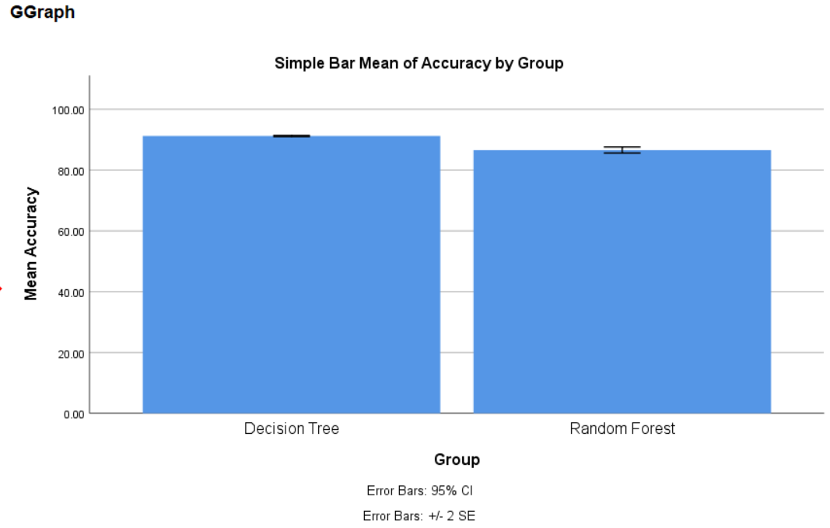

Fig 1. Bar chart showing mean accuracy
Figure 1 represents the accuracy and mean accuracy calculation of the conventional method and the proposed over selected input. The proposed Decision tree method attained a mean accuracy of 91% which is greater than the random forest method of 86%. X-axis represents accuracy of Decision tree and and random forest; Y-axis represents mean accuracy ± 2 SE.

- Discussion Framework

Based on the results obtained through independent T-test analysis, the significance value is determined as 0.001 (p<0.05) for the accuracy of two groups. The study reveals a significant difference in accuracy between the Decision Tree Model and the Random Forest algorithm, with the Decision Tree Model exhibiting a mean accuracy of 91.19%, while Random Forest has a mean accuracy of 86.59%. Literature echoes similar findings with studies [11] on support vector machine (SVM) models, reporting an accuracy of 81.3%. This consistency suggests a pattern of machine learning models contributing positively to accuracy in predicting court case outcomes.

Conversely, there are reports of varying accuracies, such as 76% for the Random Forest algorithm. These disparities underline the nuances and differences in the performance of machine learning models in [12] different contexts. Despite variations, existing literature forms a consensus that machine learning models, including Decision Trees, can substantially contribute to improving accuracy in predicting civil case verdicts. Our findings align with this consensus, emphasizing the potential implementation [13] of Decision Tree Models in real-world scenarios. This advocates for their incorporation in clinical practices or governmental policies to enhance resource efficiency and reduce waiting times.

In a broader review context, the literature presents diverse findings for various machine learning models. Our study contributes by providing evidence that supports the effectiveness of Decision Tree Models in predicting civil case judgments, offering a unique perspective in the context of legal proceedings. Acknowledging the [14] promising results, the study has limitations, including the time required for training large datasets, dataset dependencies, and sensitivity to outliers. These factors introduce complexities that should be considered when interpreting the study's outcomes.

Looking ahead, the model's applicability could be extended to real-time data streams, allowing integration with live courtroom proceedings. Furthermore, exploring the application of this model within the Indian legal landscape holds substantial potential for reshaping legal processes across diverse [15] domains. Moving forward, our research opens avenues for refining civil case judgment prediction models. Future enhancements could involve incorporating socio-economic and cultural variables to capture a more comprehensive understanding of case dynamics. The potential integration of real-time data streams, including live courtroom proceedings, stands as a promising direction for immediate case updates, thereby revolutionizing legal processes. Customizing the model to suit different legal systems, particularly within the Indian context, [16] presents an opportunity for widespread applicability, enhancing efficiency and fairness. Further exploration may involve leveraging emerging technologies like natural language processing and sentiment analysis to advance the precision of predictive capabilities.

- Conclusion

In summary, our study delves into a comparative analysis of Decision Tree Models and Random Forest Algorithms in predicting civil case verdicts. The research reveals a substantial difference in accuracy, with the Decision Tree Model demonstrating a mean accuracy of 91.19%, surpassing the Random Forest Algorithm's mean accuracy of 86.59%. This aligns with existing literature, emphasizing the efficacy of machine learning models, particularly Decision Trees, in improving accuracy in predicting legal outcomes. Despite acknowledged limitations, our findings advocate for the practical implementation of Decision Tree Models in real-world scenarios, offering valuable insights for legal professionals and researchers. Looking ahead, our model's potential extension to real-time data streams and its application within the Indian legal landscape could usher in transformative changes, reshaping legal processes across diverse domains.

REFERENCES
[1] H. Prüß, S. Köhler, and S. Müller, “Autoimmune encephalitis-Diagnostic and therapeutic decision tree from a psychiatric, neurological and ethico-legal point of view : Approach in cases of lack of ability to give consent and permissibility of compulsory treatment,” Nervenarzt, vol. 91, no. 2, pp. 122–130, Feb. 2020.
[2] M. I. Cornejo-Plaza, R. Cippitani, and V. Pasquino, “Chilean Supreme Court ruling on the protection of brain activity: neurorights, personal data protection, and neurodata,” Front. Psychol., vol. 15, p. 1330439, Feb. 2024.
[3] H. E. Miller et al., “Abortion Bans and Resource Utilization for Congenital Heart Disease: A Decision Analysis,” Obstet. Gynecol., vol. 142, no. 3, pp. 652–659, Sep. 2023.
[4] D. Morena et al., “Obstetric Violence in Italy: From Theoretical Premises to Court Judgments,” Clin. Ter., vol. 175, no. 1, pp. 57–67, Jan-Feb 2024.
[5] S. S. Nagel, Law, Decision-Making, and Microcomputers: Cross-National Perspectives. Praeger, 1991.
[6] H. D. J. Hogg et al., “Safety and efficacy of an artificial intelligence-enabled decision tool for treatment decisions in neovascular age-related macular degeneration and an exploration of clinical pathway integration and implementation: protocol for a multi-methods validation study,” BMJ Open, vol. 13, no. 2, p. e069443, Feb. 2023.
[7] P. Smith, Paul Smith Collected Poems 1970-2020: Volume Two: Ghazals & Other Rhyming Poems. 2020.
[8] J. Miles, J. Turner, R. Jacques, J. Williams, and S. Mason, “Using machine-learning risk prediction models to triage the acuity of undifferentiated patients entering the emergency care system: a systematic review,” Diagn Progn Res, vol. 4, p. 16, Oct. 2020.
[9] B. Lindell, Multi-criteria Analysis in Legal Reasoning. Edward Elgar Publishing, 2017.
[10] F. Mu, Y. Gu, J. Zhang, and L. Zhang, “Milk Source Identification and Milk Quality Estimation Using an Electronic Nose and Machine Learning Techniques,” Sensors , vol. 20, no. 15, Jul. 2020, doi: 10.3390/s20154238.
[11] N. Todd, “Demonstrating the expertise of an expert witness in the civil court: Use of a concise CV after the judgment in,” Med. Leg. J., p. 258172231191343, Feb. 2024.
[12] V. K. Brennan, G. Jones, S. Radley, and S. Dixon, “Incorporating Process Utility into Cost-Effectiveness Analysis via a Bolt-On Domain to the SF-6D: An Exploratory Study,” Appl. Health Econ. Health Policy, vol. 19, no. 5, pp. 747–756, Sep. 2021.
[13] D. M. Katz, M. J. Bommarito 2nd, and J. Blackman, “A general approach for predicting the behavior of the Supreme Court of the United States,” PLoS One, vol. 12, no. 4, p. e0174698, Apr. 2017.
[14] C. Hanretty, A Court of Specialists: Judicial Behavior on the UK Supreme Court. Oxford University Press, 2020.
[15] E. L. Hill et al., “Risk factors associated with post-acute sequelae of SARS-CoV-2: an N3C and NIH RECOVER study,” BMC Public Health, vol. 23, no. 1, p. 2103, Oct. 2023.
[16] N. Taptiklis, M. Su, J. H. Barnett, C. Skirrow, J. Kroll, and F. Cormack, “Prediction of mental effort derived from an automated vocal biomarker using machine learning in a large-scale remote sample,” Front Artif Intell, vol. 6, p. 1171652, Aug. 2023.

